CSC 124-N801 Project 2

Gregory Campbell

Histograms

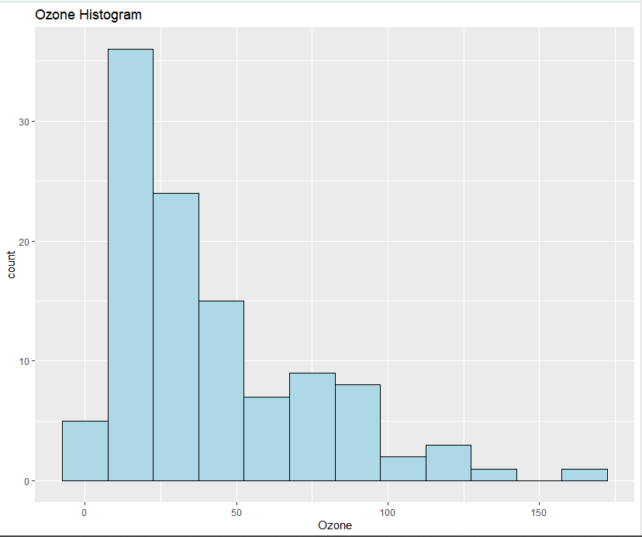

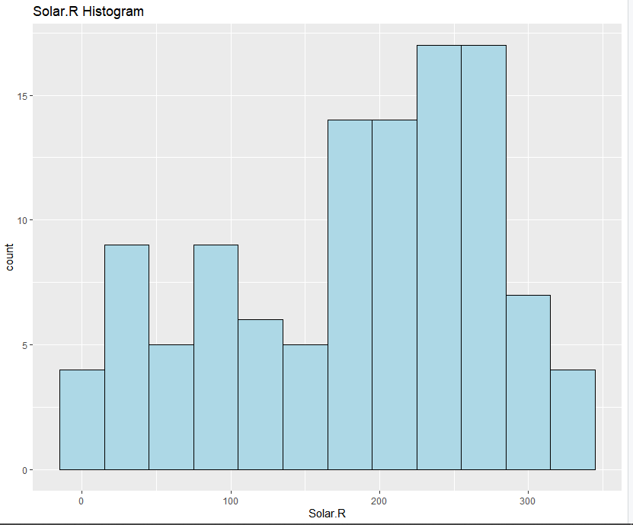

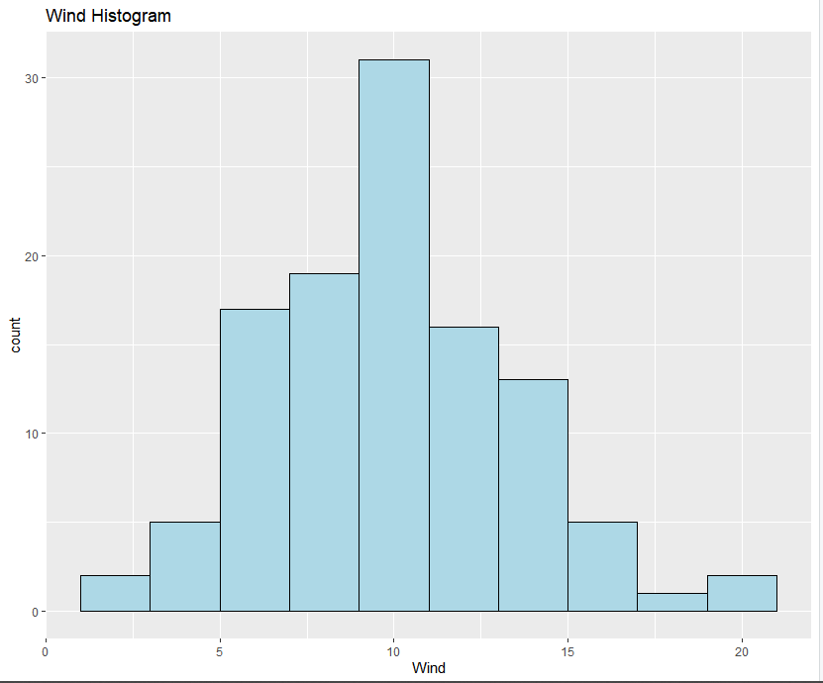

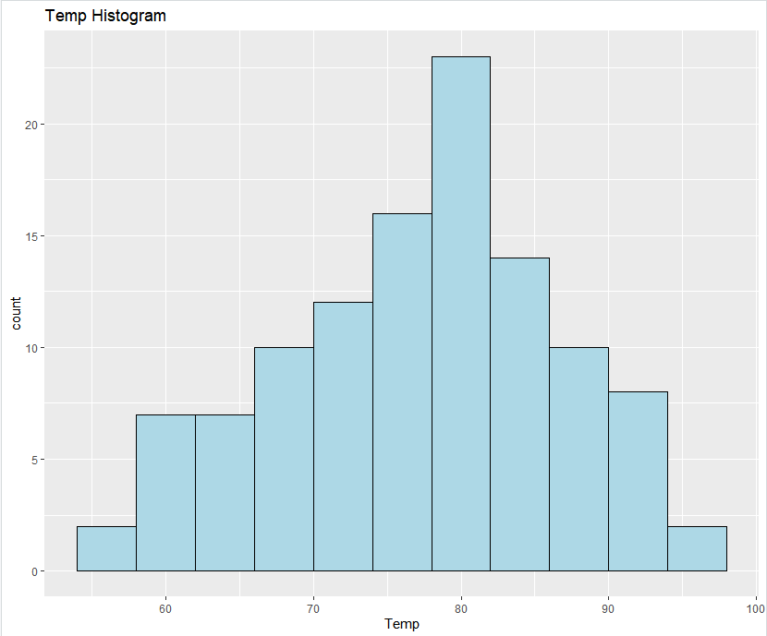

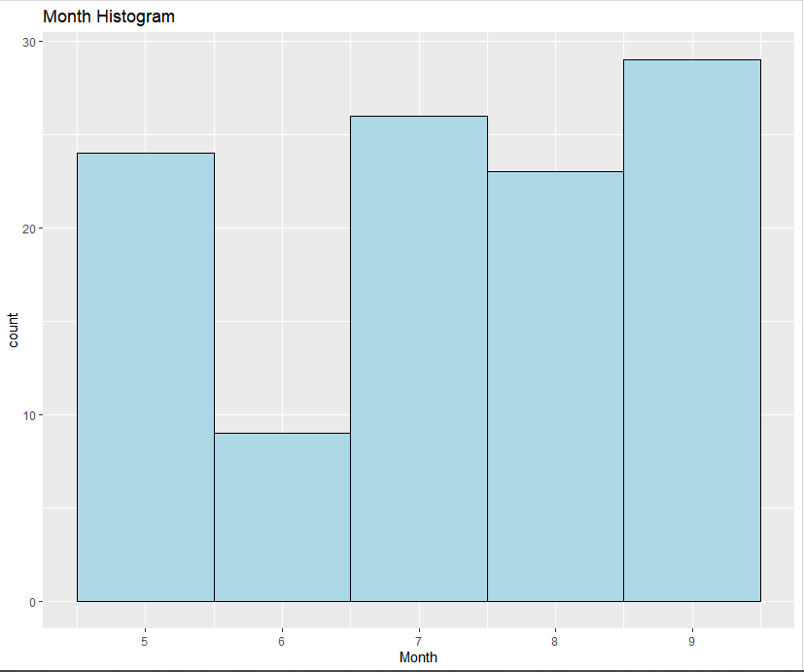

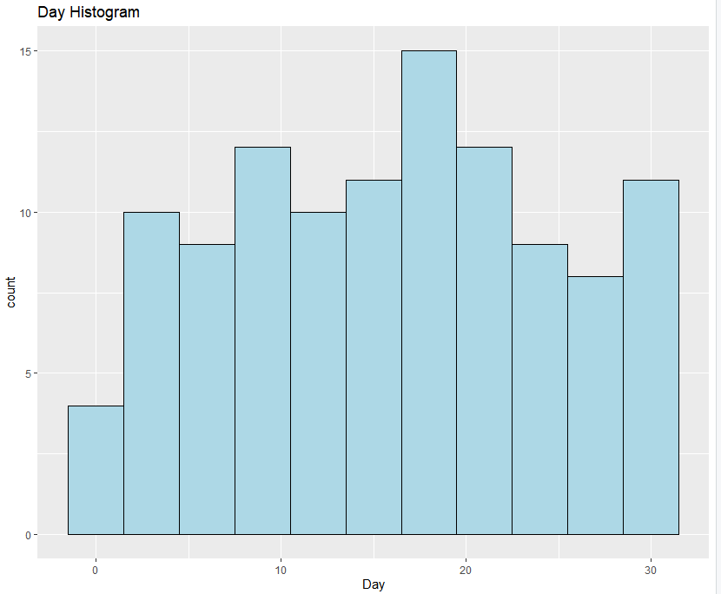

Histogram Analysis

The Ozone and Solar.R histograms are both skewed: Ozone to the right, Solar.R to the left. This appears to show a regular range of measurements with some outliers. The Wind and Temp histograms are both normally distributed, so we can use these histograms to predict future observations. Wind speeds in this area will be between 5-17 most of the time during this time of year. Temperatures will be between 65-90 during the same period. Not very useful are the Month and Day histograms. The variation in these histograms is due entirely to missing data points and the fact that different months have different numbers of days.

Boxplots

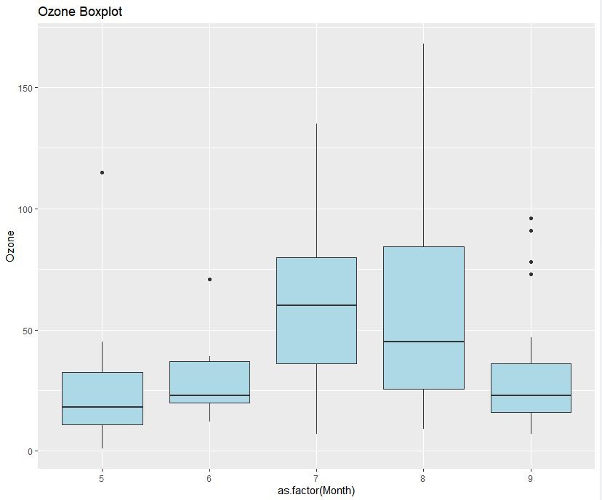

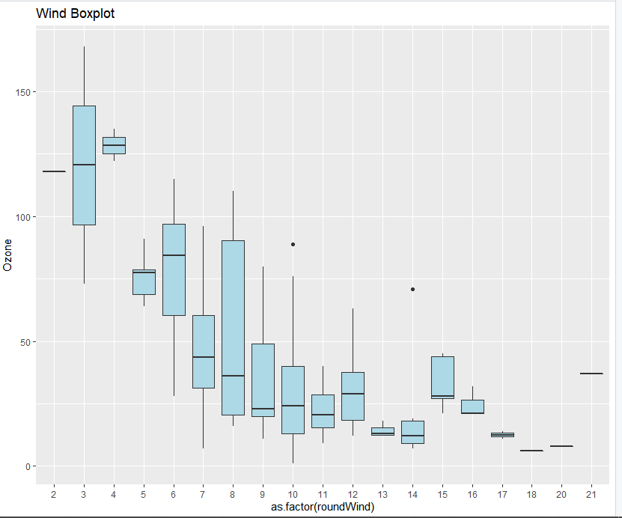

Boxplot Analysis

The Ozone boxplot shows a pattern of elevated levels in July and August. The Wind boxplot shows significantly higher levels of ozone when wind speeds are low. There is a fair amount of variation at different levels of wind speed, indicating that wind speed alone doesn’t account for ozone levels.

Line Charts

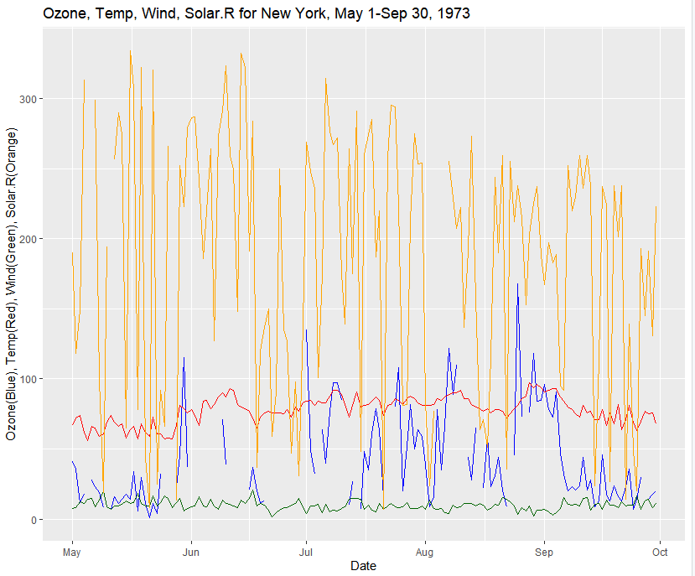

Line Chart Analysis

I use only the one chart with all four lines for brevity. Missing data from the Ozone and Solar.R variables shows in the chart, but conclusions can still be drawn. Solar radiation appears to have a general downward trend during this time of year, though with wide daily variation. The Temp and Wind variables seem to vary in lockstep as their lines fit each other nicely. While the Ozone line does not fit the Temp and Wind lines as nicely, it does seem to vary in the same way, with a scalar product affecting its values. It makes sense that these variables vary as they do: Solar.R is dependent solely on the Sun; Ozone, Temp, and Wind are internal to Earth’s atmosphere and thus vary independently, or at least co-dependently, from Solar.R.

Heatmap

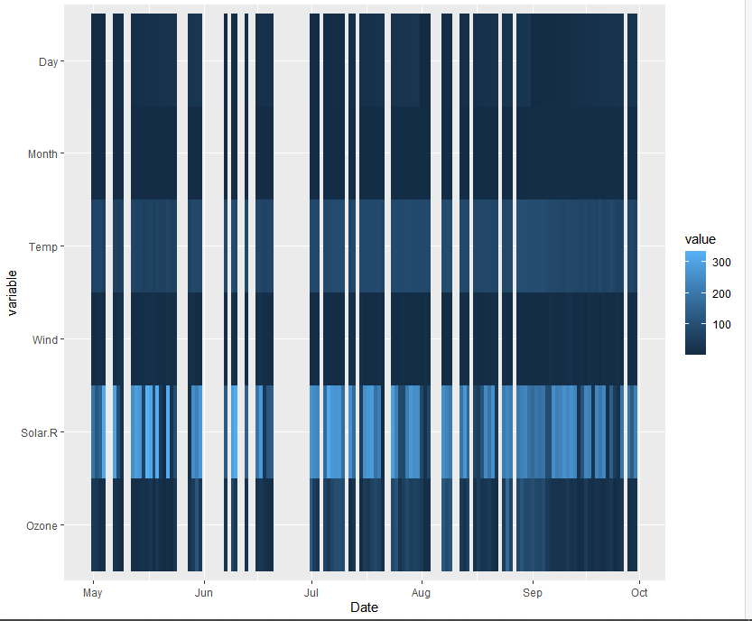

Heatmap Analysis

I’m not entirely sure what I’m looking at here. Day and Month have no meaning in terms of a heatmap. The banding patterns look similar for Temp, Wind, and Ozone but with different colors. It’s not as easy to draw conclusions from this as it is from the stacked line chart.

Scatter Chart

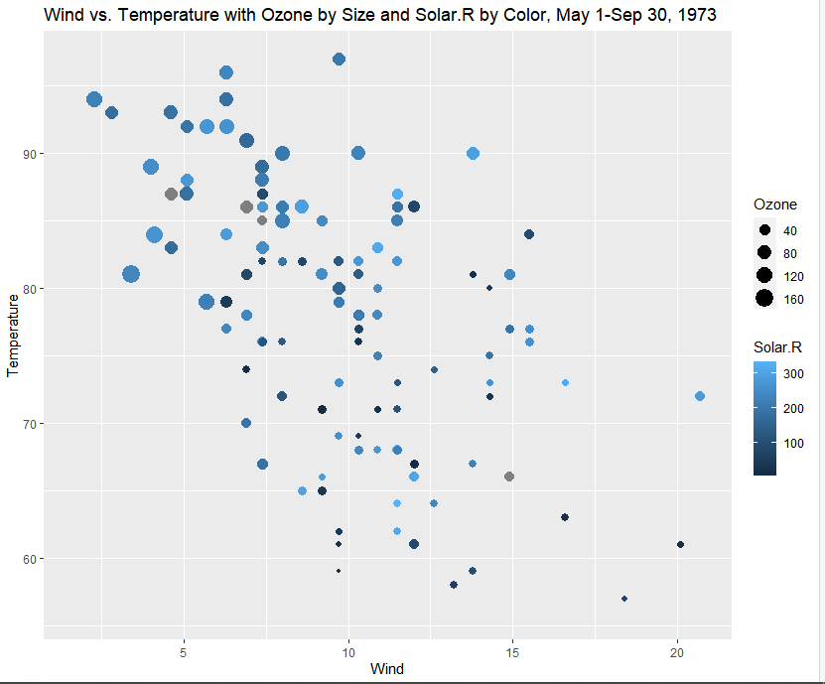

Scatter Chart Analysis

This is the most useful visualization in my opinion because it shows, at a glance, the relationship between the variables that required a bit of study with the other charts. Large values for Ozone are clustered where Temp is high and Wind is low. From the line chart it is apparent that Temp, Wind, and Ozone vary in a similar manner, but from this chart we can see clearly that the scalar mentioned in the Line Chart analysis for the Ozone variation depends on the interaction of Temp and Wind. It’s a bit difficult to discern a pattern for the Solar.R.